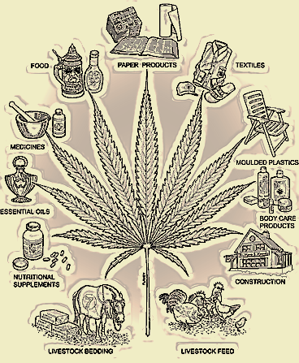
and for over 25,000 products.
Marijuana can be used for 5,000 textiles
Marijuana has no related deaths in history!
Tobacco kills 480,000 people every year in the United States! Alocohol kills 85,000 people every year in the United States!
Marijuana would be second to corn as a cash crop in industry today!

The American Medical Association promotes the compassionate use of marijuana in a carefully controlled program designed to provide symptomatic relief for nausea, vomiting, cachexia, anorexia, spasticity, acute or chronic pain, or other palliative effects.
16 out of the
50 States
Have
Legalized
Medical
Marijuana

