Joshua Hammond
Professor Packer
English 1010
9 October 2011
Incarceration in America
Stephanie Watters Flores’s political art piece, “Overcrowding,” was a stand against the American judicial system. Flores was given the assignment while she attended Indiana University. The subject was to create a series of posters that represented the problem of overcrowding in the prison system. Flores has a lot of experience in creating an art piece on this subject. She has her masters in Fine Arts, Studio Art, with a concentration in graphic design. Currently she is an adjunct professor at The Art Institutes, Online Division.
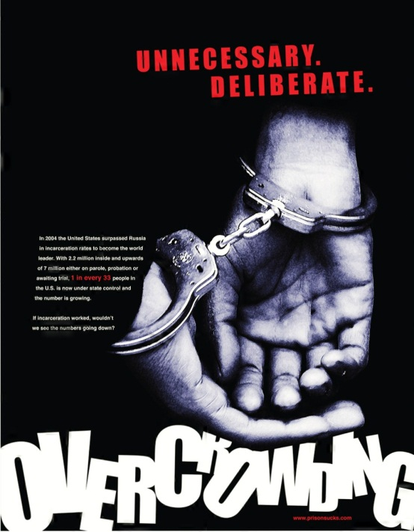
In 2004, the United States had a greater share of its population incarcerated-737 per 100,000 residents-more than any other country on the planet. Flores puts a bold message in her art piece, claiming that we need to change the overcrowding problem. The facts and images that she uses clearly state that we need to help people better themselves and not just throw them in prison. By locking people up we are just throwing tax payers’ dollars away on a lost cause. Flores’s political art piece is presented in an effective way, using emphasis and contrast to depict the logos in her art to convince the American people that overcrowding in the prison system is a serious problem.
Flores uses raw facts in her piece to emphasize the serious problem in the prison system.
In 2004 the United States surpassed Russia in incarceration rates to become the world leader. With 2.2 million inside and upwards of 7 million either on parole, probation or awaiting trial. 1 in every 33 people in the U.S. is now under state control and the number is growing.
By using bold red lettering in her art piece it draws your attention to the wording, emphasizing what she sees as most important. She sets a large pair of hands in handcuffs as the main picture of the piece, centering it to give more of an impact. Above it in bright red letters she puts, “UNNECESSARY, DELIBERATE,” to make the audience think about the problem of overcrowding. It adds to the art piece and brings the change of thinking into the piece of unnecessary and deliberate incarceration.
Flores uses contrast by using the white on black background and the red on black background. By comparing the United States to Russia she puts a great sense of contrast between the countries. Russia is a much larger than the U.S., but we still have more people incarcerated. It brings a deeper message to the art piece by contrasting a large country to a much smaller country, making the problem seem much bigger and out of control.
Flores uses emphasis and contrast to depict the logos in her art piece. She states that, “2.2 million people are incarcerated and upwards of 7 million are on parole, probation or awaiting trial.” By emphasizing these facts it makes her message very clear and logical for the American people to understand. With the raw facts and pictures that she uses to emphasize and bring contrast to her piece, makes the logic more understandable for the people to see that there is a problem in the American prison system. The contrast of a larger country gives the impact of how serious the overcrowding problem is. She concludes her piece with a question, “If incarceration worked, wouldn’t we see the number going down?” With this ending question she gets the reader to change their thinking and create their own opinion on the subject. This leads the American people to consider the problem and use their opinion to come to their own conclusion.

